Introduction

Lesson Introduction





### **What We Will Cover In This Lesson**

Nice to see you again. This lesson will focus on Agile Frameworks, with the topic being covered as follows:

* Introduction to Agile Frameworks in general and what the advantages are of using a framework.
* The Scrum Framework and its unique characteristics as a valuable Framework.
* The more lightweight Kanban Framework and its unique advantage in managing flow and WIP
* The XP Framework and its advantages, with an appreciation for its more stringent best practices.

### **By the End of the Lesson You Will Be Able To...**

* Identify the advantages of using a framework
* Identify the specific and shared characteristics of Scrum, Kanban, and XP frameworks
* Determine which frameworks are appropriate for a given project
* Identify the core team roles assign team members to each role
* Implement best practices for each framework, including ceremonies and artifacts



What We Will Cover In This Lesson

# Why Agile Frameworks?

## Why Do Agile Frameworks Matter?













### **Agile Frameworks Are A Vehicle for Practically Utilizing Agile**

Agile's principles related to simplicity, adaptability, and the ability to embrace change attract attention. For Agile to practically be utilized effectively, an Agile Framework, or a combination of frameworks, is usually adopted.

### **Similarities Between Agile Frameworks:**

* Adhere to the Agile Mindset as being fundamental to the success of any Agile journey
* Emphasize that being Agile is critical to successfully doing Agile
* The Agile Manifesto’s 4 paired core values and its associated 12 guiding principles set the foundation for all Agile Frameworks
* Provide guidance on how to bring the Agile Manifesto’s core values and principles to life







### **Additional Resources**

* [**The Best Framework to Use for a Successful Agile Transformation(opens in a new tab)**](https://www.projectmanagement.com/blog-post/62476/The-Best-Framework-to-Use-for-a-Successful-Agile-Transformation): In this blog post, Al Shalloway walks through the value of Agile Frameworks.

# How Experts Approach Agile Frameworks

## Thinking About Agile Frameworks





















### **Agile Frameworks are Enablers that Bring to Fruition the Value of Agile**

This includes:

* Focusing more on the individuals and interactions; ultimate determining factor for the success of a product are the resources on the Agile product delivery team.
* Do not force Agile unnecessarily; Teams that are already performing well can be gradually introduced to additional Agile practices based on a specific Agile Framework.
* Refined user stories are important; Agilists work with Product Owners to ensure the user stories have been sufficiently refined for the Agile Team to proceed.
* Respect the backlog; Agilists focus on ensuring the Agile Team does not over-commit to what can be accomplished in each iteration, especially during the first few iterations.

### **Implementing a Specific Agile Framework is a Fine Balancing Act**

* Must adapt based on each organization’s unique culture and context.
* Experts have to regularly remind both leaders and the Agile Team to remember that there is no one way to execute Agile practices in an organization.
* Agile principles and practices are by their very nature to be adapted as needed.



Framework “Balanced” with Organizational Context







### **Additional Resources**

* [**Advanced Topics in Agile Planning(opens in a new tab)**](https://www.mountaingoatsoftware.com/presentations/advanced-topics-in-agile-planning): In this presentation, Mike Cohn walks through Advanced Agile Planning.

# Agile Frameworks

## What Are Agile Frameworks?

















### **Agile is an Umbrella Term for a Variety of Frameworks that Align with The Agile Manifesto**

Every Agile team's goal is to deliver value-driven functionality with built-in quality and to do it quickly. This is where **Fail Fast and Learn** is priceless. Agile teams who wish to deliver both amazing product features that delight customers, as well as do it fast, must learn to quickly change course when it is realized that a product feature is heading down the wrong path.

### **The Agile Umbrella**

The Agile Umbrella has some key characteristics:

* **Deliver Value**: An absolutely key driver behind anything Agile is to deliver value.
* **Continual Improvement**: Agile promotes incremental improvement to minimize resistance from all who are involved.
* **Flexibility**: Flexibility is one of the foundations of any Agile Framework.
* **Trust and Respect**: Agile Frameworks promote trust and respect because such trust and respect motivate Agile teams.
* **Cultivate Mastery**: This built-in structure for Agile team members to hone their skills further motivates the Agile team.



The Agile Umbrella

### **New Terms**

* **Agile Umbrella**: A term that refers to the various Agile Frameworks that follow the Agile Manifesto's values and principles

### **Additional Resources**

* [**Five Powerful Enterprise Agile Frameworks(opens in a new tab)**](https://dzone.com/articles/five-powerful-enterprise-agile-frameworks-1): In this blog, Prabhu Arumugham walks through five Enterprise Agile frameworks that act as process 'blueprints' providing a set of Agile practices, organizational structure, roles, and other recommendations.

# Quizzes: Agile Frameworks

## Thinking About Agile Frameworks







Exercise: Agile Frameworks

The Benefits of Agile Frameworks for SocialKare.gov

How would SocialKare.gov benefit from using an Agile Framework? Review the [**SocialKare.gov Case Study(opens in a new tab)**](https://video.udacity-data.com/topher/2020/September/5f5f6bc7_agnd-c1-foundations-of-agile-socialkare.gov-case-study/agnd-c1-foundations-of-agile-socialkare.gov-case-study.pdf) and identify at least three benefits of using an Agile Framework at SocialKare.gov. Explain how those benefits will help SocialKare.gov be more effective in reaching its goals.







# Solution: Agile Frameworks

## My Solution





### **Identify Three Benefits of Using an Agile Framework**

SocialKare.gov will benefit from:

* Years of experience that a proven Agile Framework has been built upon and further refined over time at many organizations globally.
* By using a proven framework, there’s a higher level of predictability for SocialKare.gov.
* SocialKare.gov will benefit from higher quality product delivery.
* An Agile Framework allows for customizing and adapting the Framework to better align with the organization.





# Scrum

## What Is Scrum?

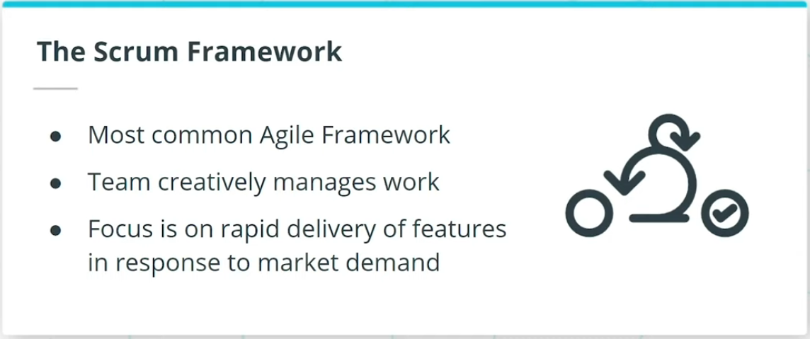

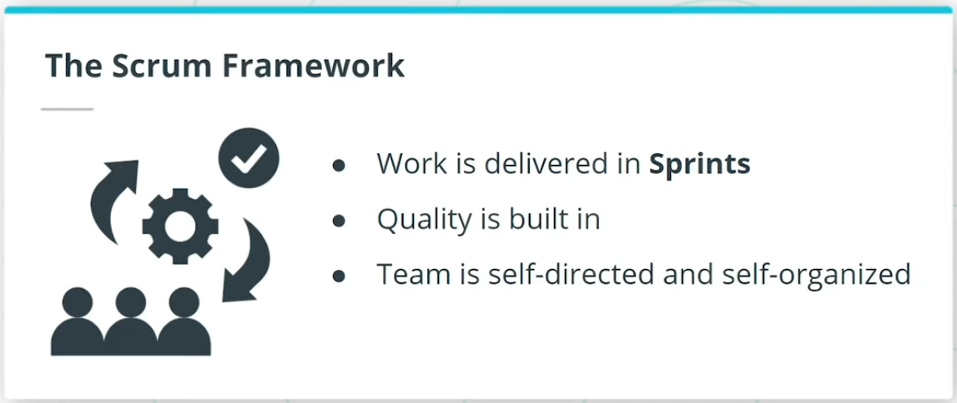

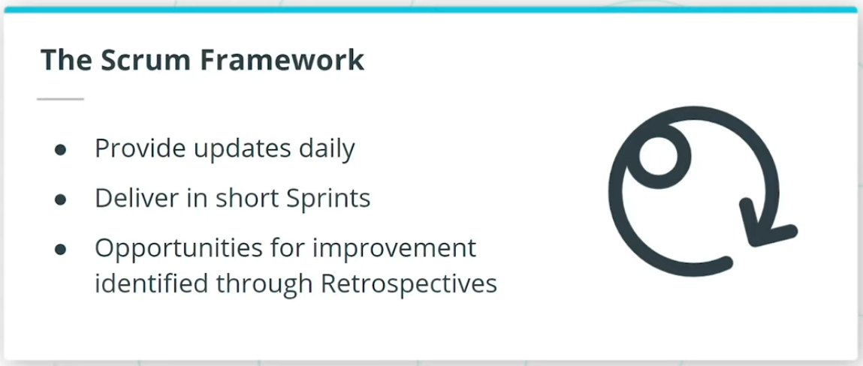

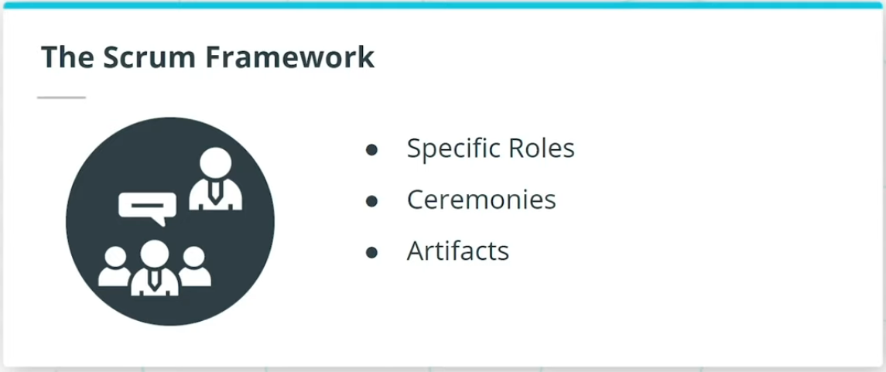

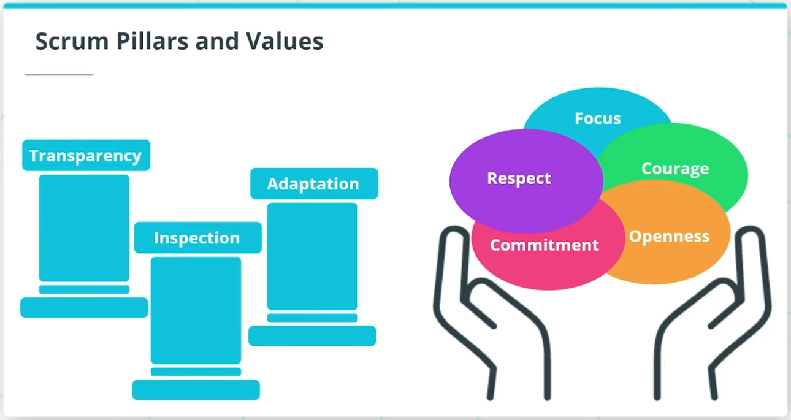

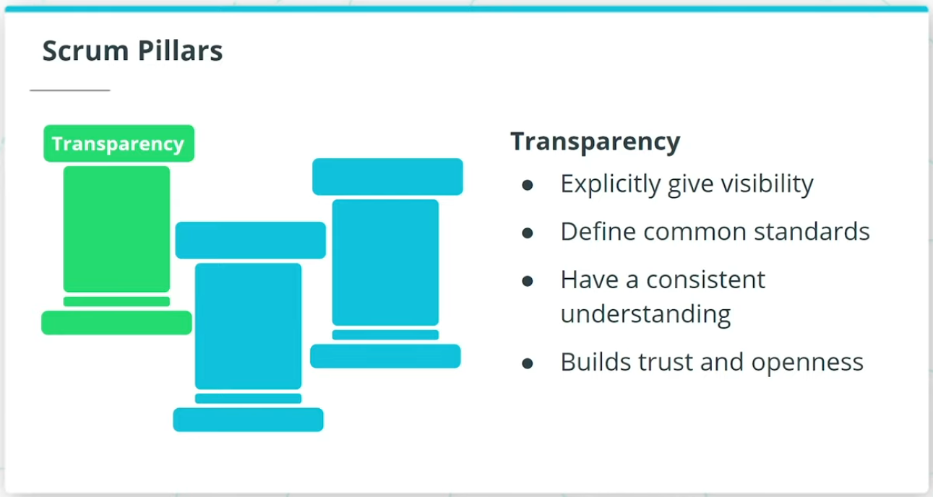

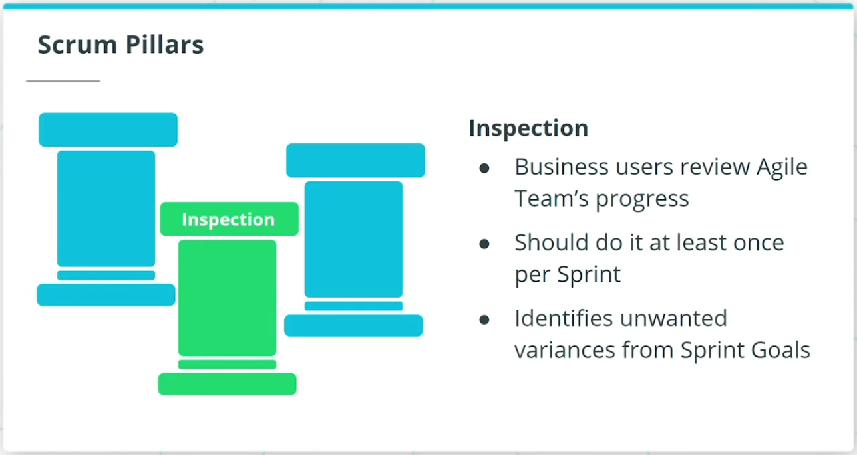

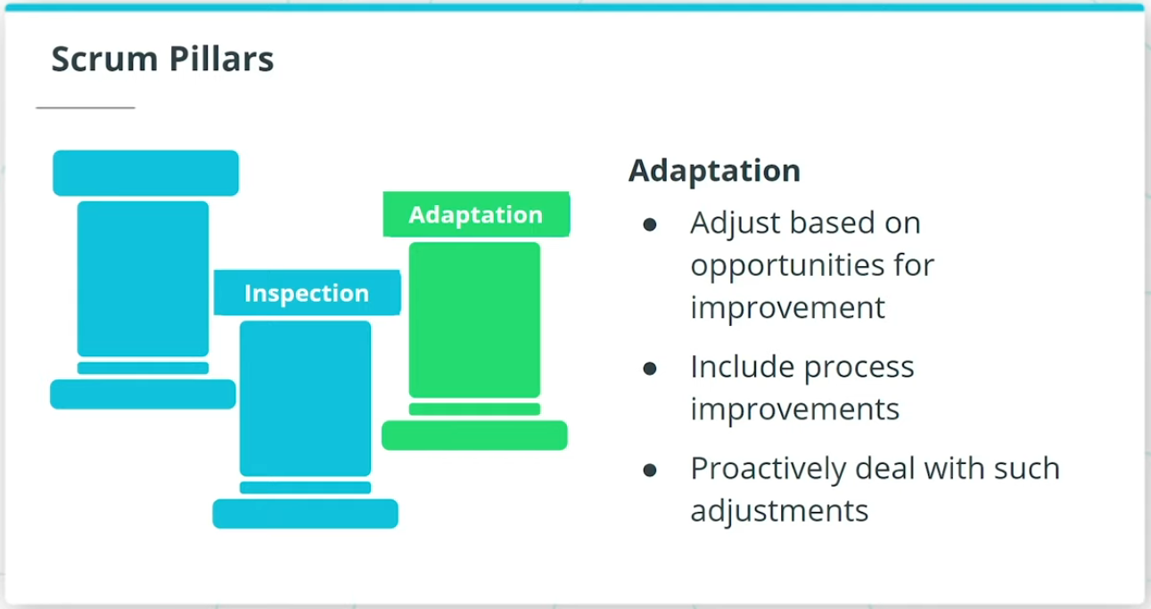

### **Scrum Framework**

Scrum is by far the most common Agile Framework.

* The features are delivered in iterations known as Sprints.
* The Team conducts Daily Stand-Ups in which they provide updates to each other.
* Retrospectives are conducted to identify opportunities for improvement at the end of each Sprint.
* Specific roles, as well as certain Ceremonies, are recommended in the Scrum Framework.

### **Scrum Pillars**

* **Transparency** - Transparency builds trust and openness both within the Agile Team, as well as with those stakeholders outside the Agile Team.
* **Inspection** - Inspection involves the business users reviewing the Agile Team’s progress towards the defined goals.
* **Adaptation** - Agile Teams adjust and adapt based on opportunities for improvement that are identified either by the Agile Team themselves or through feedback from others outside the team.

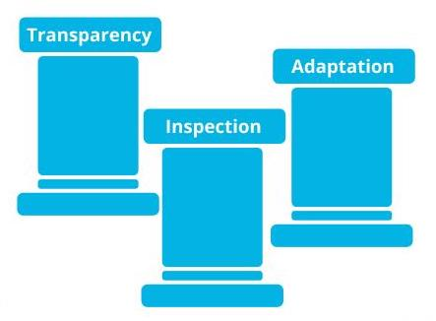

Scrum Pillars: Transparency, Inspection and Adaptation

## Scrum Values

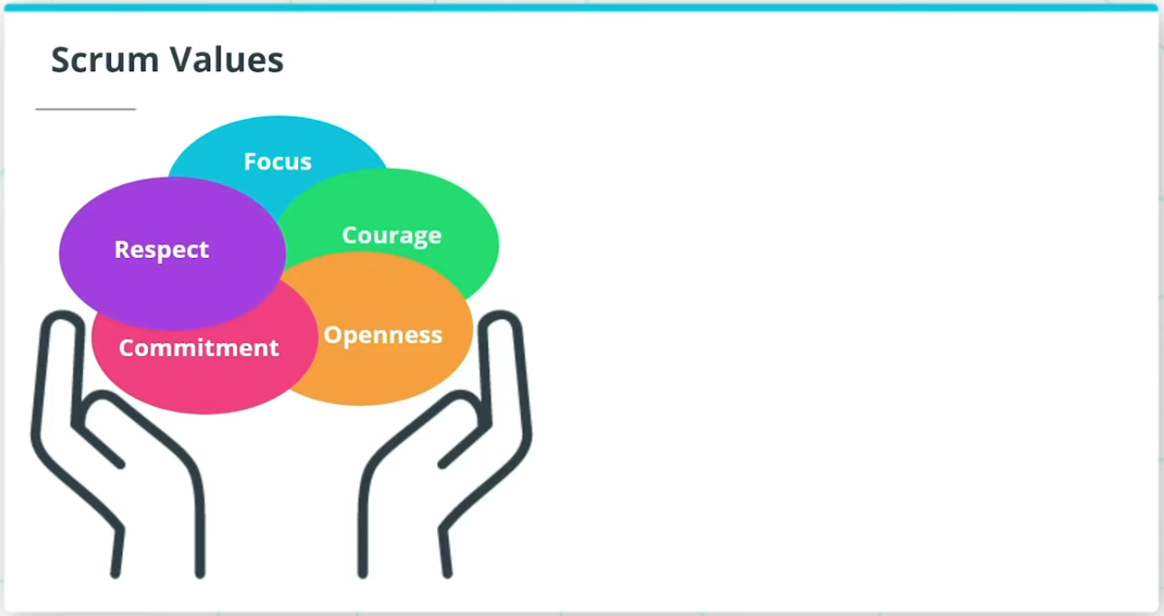

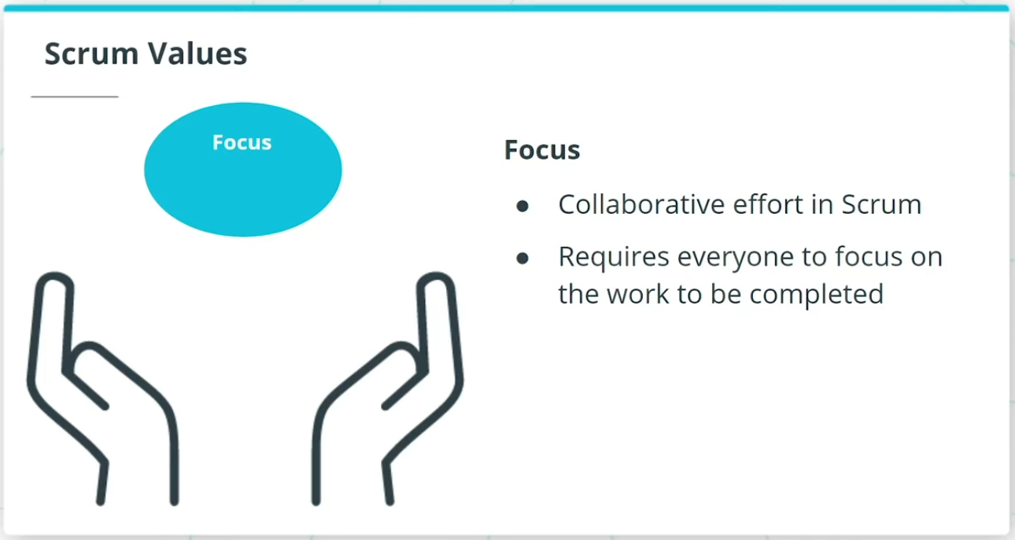

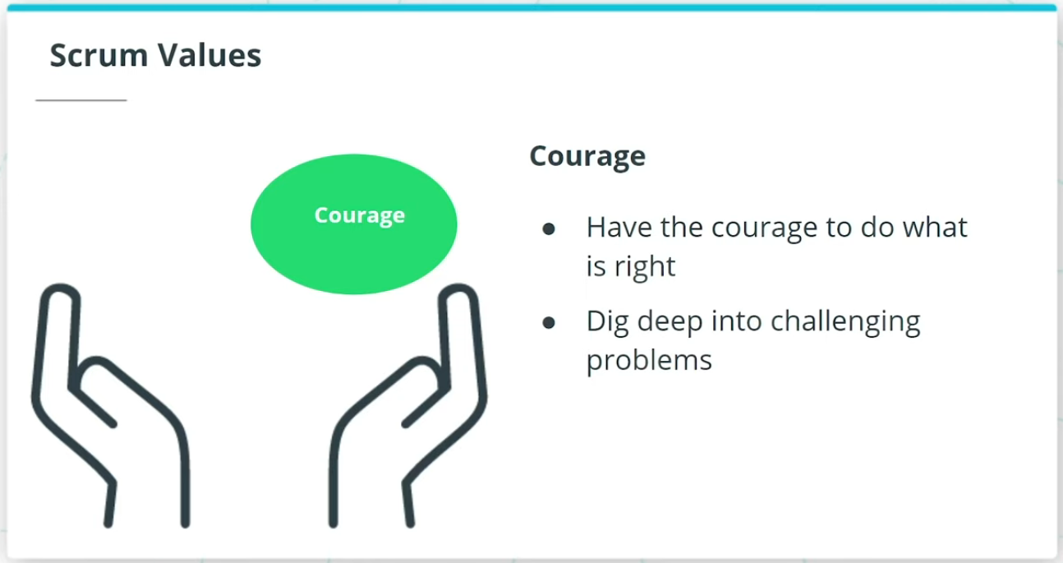

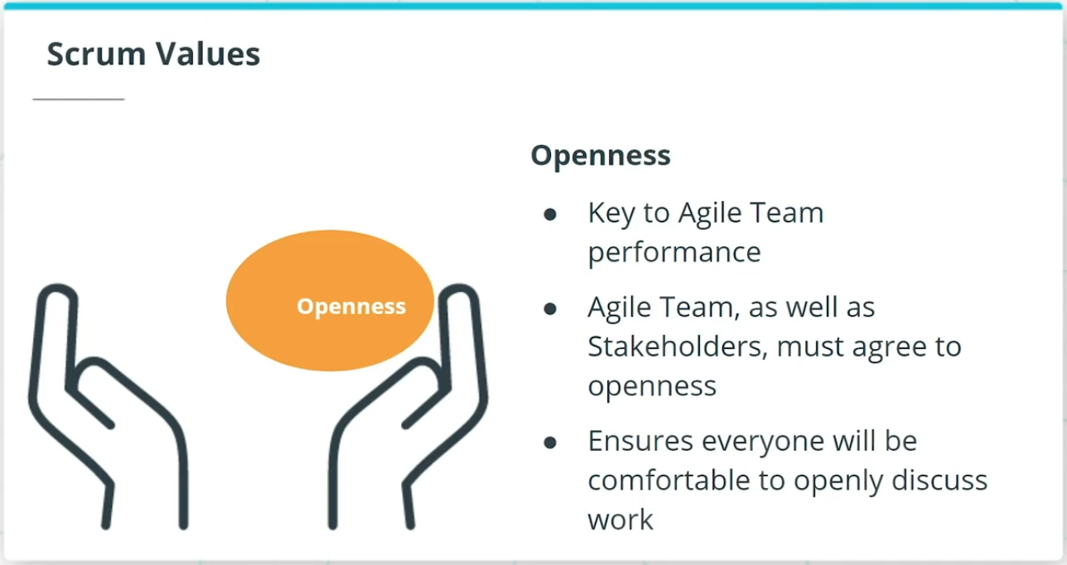

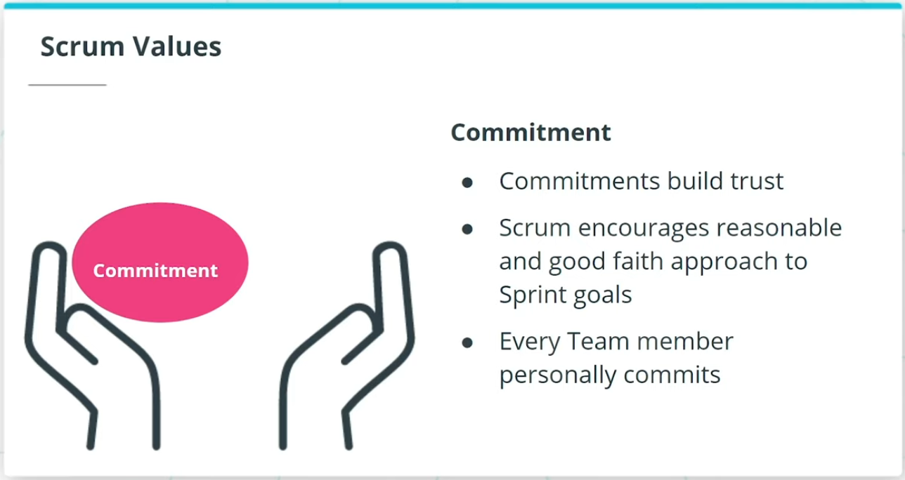

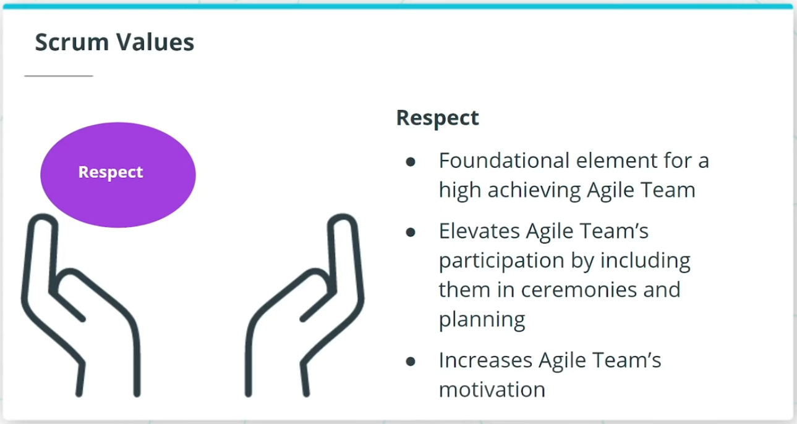

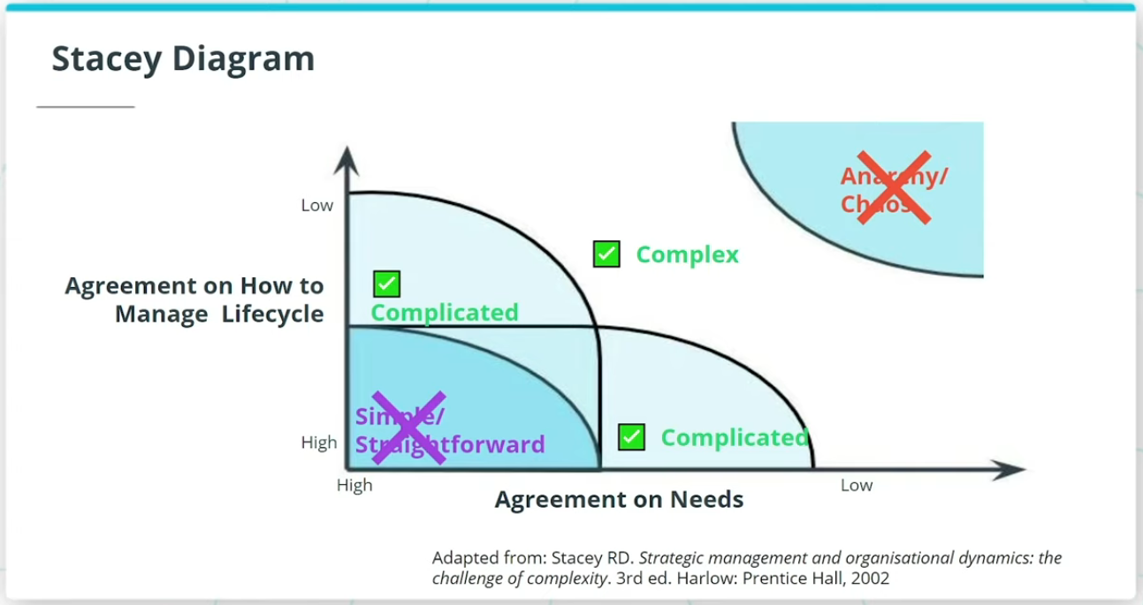

### **5 Scrum Values**

* **Focus** - Everyone in the Team focuses on the work to be completed in order to deliver the Sprint goals.
* **Courage** - Members of the Team need to have the courage to do what is right to ensure the Sprint goals are met.
* **Openness** - The Team and its stakeholders agree to a culture of openness.
* **Commitment** - Commitments build trust within the Agile Team members, as well as with the business users and leaders.
* **Respect** - Respect is a key in Scrum for a high-achieving Agile Team.

### **When Scrum Does Not Make Sense**

As shown in the Stacey diagram, an Agile Framework like Scrum works best with complex and complicated projects and products. There may not be much value in utilizing Agile principles

* when there is a near certainty in both the requirements and process upfront.
* when there is chaos. Scrum cannot bring value to an environment where there is no vision or clear roadmap.
* when the project is simple and predictable and the need for iterative learning and adapting is of no value.

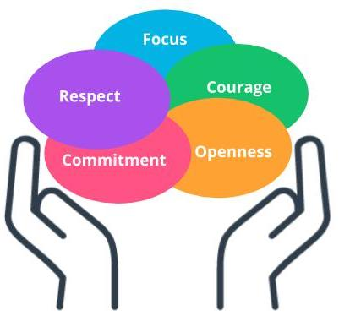

Scrum Values

### **New Terms**

* **Scrum**: Scrum is one of the most popular Agile frameworks for developing complex products, with an emphasis on value delivery
* **Scrum Pillars**: Transparency, Inspection, Adaptation
* **Scrum Values**: Focus, Courage, Openness, Commitment, Respect
* **Sprint**: A Sprint in Scrum is a repeatable fixed time-box iteration during which a minimum shippable product is delivered

### **Additional Resources**

* [**Scrum Guide(opens in a new tab)**](https://www.scrum.org/resources/scrum-guide?gclid=Cj0KCQjwhIP6BRCMARIsALu9LfnAyjv8_sgGwYw7igmvP6xYi0kb9-lwQv0M6FWeO5I0O2ZNSj9Uv_QaAqOKEALw_wcB): The Scrum Guide provides complete details on the Scrum Framework.
* Kenneth Rubin. ***Essential Scrum: A Practical Guide to the Most Popular Agile Process: A Practical Guide To The Most Popular Agile Process***. Pearson, 2013.  
  This book is a comprehensive guide to the Scrum framework.